**Thesis update**

**Random Forest  
**

**Support Vector Machine**

**Multi-Layer Perceptron**

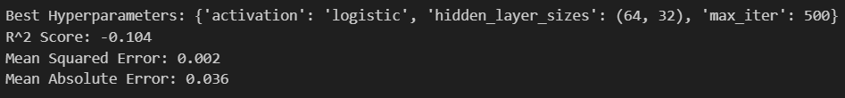

**KNN**

